IMMERSE YOURSELF IN 21ST CENTURY TECHNOLOGY Expo
Date: MARCH 26TH & 27TH, 2009
Location: ASNUNTUCK COMMUNITY COLLEGE
170 ELM ST, ENFIELD, ct 06082

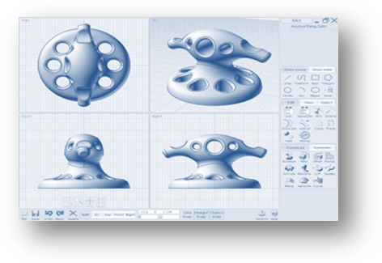
Come join us at Asnuntuck Community College for an expo showcasing manufacturing technologies beyond your imagination! Asnuntuck Community College, in collaboration with the College of Technology’s Regional Center for Next Generation Manufacturing and RapidTech, bring you Additive Manufacturing Technologies that are used in modern manufacturing, art, animation, medical modeling, architecture, aerospace and the automotive industry.

See vendor presentations of actual applications/ case studies and witness demonstrations highlighting:
- 3D digitizing which allows you to capture and store an exact 3D computer model of any object from a small discrete part of an actual city block.
- 3D drafting which allows you to conceptualize parts and assemblies in 3D space.
- 3D printing which allows you to create the real model.
Participants will be exposed to state-of-the-art, hands-on model making and additive fabrication technologies that create physical objects from virtual designs through the use of computer aided drafting (CAD).

Expo participants will include industry, legislators, faculty members from community college and 4-year colleges/ universities and community college and high school students.
KEYNOTE SPEAKER: TERRY WOHLERS
For the past 27 years, Terry Wohlers has focused his education, research, and practice on design and manufacturing. Over this time, he has authored nearly 350 books, articles, and technical papers on engineering and manufacturing automation. In August 2007, Wohlers was voted the #1 most influential person in rapid product development and rapid manufacturing by TCT Magazine (UK) in its TCT Top 25 Influential People survey.
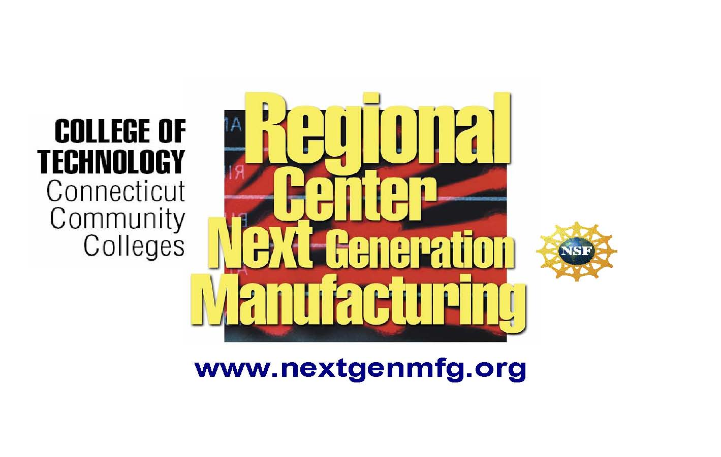
Wohlers has been quoted in The Boston Globe, Business 2.0, BusinessWeek, Chicago Tribune, Discovery News from the Discovery Channel, The Economist, FORTUNE, Forbes, Los Angeles Times, San Francisco Chronicle, Scientific American, The Wall Street Journal, and countless domestic and foreign magazines, journals, and newspapers. In 1994, Wohlers presented a special briefing on the economic impact of additive fabrication to the Under Secretary for Technology at the U.S. Department of Commerce.
SPONSORED BY:

AGENDA: March 26th & 27th
Thursday, March 26, 2009
8:00am-10:00am First Group of Students Arrive and Explore 21st Century Technology Expo: Tracks 1,2,3
9:30am-11:30am Second Group of Students Arrive and Explore 21st Century Technology Expo: Tracks 1,2,3
11:30am-1:30pm Third Group of Students Arrive and Explore 21st Century Technology Expo: Tracks 1,2,3

5:00pm- 7:30pm Buffet and Ice Cream Social
Welcome Remarks from President Martha McLeod
Keynote Speaker: Terry Wohlers

Friday, March 27, 2009
7:30am-8:00am |  | Registration
8:00am-9:00am |  |  | Breakfast and Social Hour
 |  |  | Welcome Remarks: President Martha McLeod
 |  |  | Remarks: Congressman Joe Courtney
9:00am-9:45am |  | Keynote: Terry Wohlers
9:45am-11:15am |  | Explore 21st Century Technology
FOR QUESTIONS, PLEASE CONTACT CHRIS CASEY AT CWSMCASEY@COX.NET OR VIA PHONE AT (860) 698-6267.

SPONSORED BY:

